Income Manager

Unity Housing Association

Applicant Information Pack

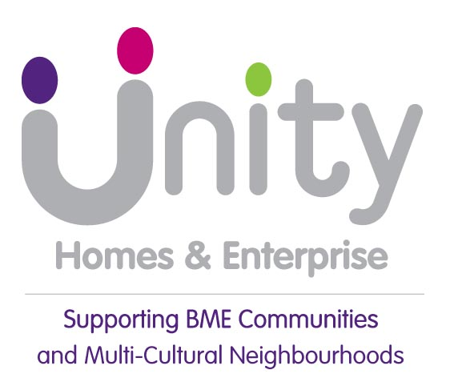

Hello!

Thank you for having an interest in working for Unity.

We are a successful, independent and ambitious housing association driven by social purpose, supporting BME communities and multi-cultural communities across Leeds and Kirklees.

We are proud to call ourselves a BME association, part of the national BME housing movement, and believe that is as important today as it was when we were founded over 35 years ago.

Our social purpose is at the heart of everything we do, it states: ‘we will fight inequality and empower BME people to improve their lives by creating opportunities and helping to regenerate communities’.

The role of the Income Manager is a great opportunity to join a team that not only supports people but wishes to improve and drive the business forward.

We are looking for someone with a housing management background who has experience in all aspects of managing and developing people. Someone who is innovative, dynamic and leads by example demonstrating our Unity values in all that they do.

If you are confident you can deliver and are up for the challenge, then we’d love to hear from you.

I believe this is a brilliant opportunity to make a difference and I look forward to receiving your application.

Yours sincerely



Cedric Boston
Chief Executive

Advert: Income Manager – strictly no agencies

Working Location: You will be based at our office at 113-117 Chapeltown Road, LEEDS,
LS7 3HY.

Salary: Circa £47,000

Hours of Work 35 hours per week, to be worked over Monday to Friday

Benefits: 27 days leave plus bank holidays, Occupational Pension Scheme, flexible working and family-friendly policies.

Make a real difference and help shape the future of our services
We are looking for an experienced and motivated Income Manager to lead our Income Management Team, ensuring we protect and maximise the organisation's income while providing excellent support to our customers.
In this key leadership role, you will inspire, manage and motivate a high-performing team, fostering a culture of continuous improvement, accountability and personal responsibility. You will play a vital role in helping customers sustain successful tenancies by ensuring access to welfare benefits advice, income maximisation support and other appropriate services.
What you'll be doing
- Leading and developing the Income Management Team to deliver excellent performance and customer outcomes.
- Driving a positive, high-performing culture focused on continuous improvement and accountability.
- Ensuring customers receive appropriate support and advice to maximise their income and maintain successful tenancies.
- Overseeing the management and processing of rental income, ensuring efficiency, accuracy and compliance with financial regulations and audit requirements.
- Working collaboratively across the organisation to improve services and deliver positive outcomes for customers.
About you
We're looking for someone who brings:
- Experience of leading and motivating teams to achieve excellent results.
- Strong knowledge of income management, rent collection and income recovery practices.
- An understanding of welfare benefits and the challenges faced by customers in sustaining tenancies.
- Excellent communication, leadership and stakeholder management skills.
- A commitment to delivering outstanding customer service and continuous improvement.

Why join us?
This is an exciting opportunity to apply your skills, experience and knowledge in a role where you can make a genuine impact. You'll work alongside passionate and supportive colleagues and play a key part in delivering our ambitious plans for the future.
Diversity and Inclusion
We are committed to building a diverse and inclusive workforce and warmly welcome applications from all sections of the community. We believe that a variety of perspectives, backgrounds and experiences makes us stronger and helps us deliver better outcomes for our customers.

Applying for this job
To arrange an informal discussion about the role, please contact ann.foster@unityha.co.uk
or 07593 561600 in the first instance.

Whilst we are interested in your work history and experience, demonstrating behaviours, skills, abilities and knowledge and experience can come from a variety of life experiences, not just paid employment. Please feel free to use examples from all areas of your life that are relevant to the requirements of the role. We also want you to tell us why you have a passion for working for Unity and why you are the colleague we need.
To apply, please submit your CV together with a covering letter demonstrating how you meet the person specification of the role to recruitment@unityha.co.uk.
Be yourself!
Please ensure your CV and letter are your own work and genuinely reflect your experience, achievements and motivations. We are looking to understand you as a candidate, rather than any content generated by AI tools.

If you are selected for an interview, you will be asked to provide photo identification and proof of eligibility to work in the UK.

Due to the volume of applications, we reserve the right to withdraw this vacancy at any time, so please apply as soon as possible.

Closing date: 21 September 2026 midnight.

UNITY HOUSING ASSOCIATION
Job Description

INCOME MANAGER

Team/Directorate: INCOME MANAGEMENT/HOUSING OPERATIONS
Responsible for: INCOME MANAGEMENT OFFICERS x 2
Responsible to: DIRECTOR OF HOUSING OPERATIONS

- JOB PURPOSE

  - Lead, manage and motivate the Income Management Team to protect and maximise the income of the organisation. Drive a performance culture with a focus on continuous improvement, accountability and personal responsibility.
  - Lead and provide a provision of services to ensure that our tenants are provided with support, including welfare benefit advice to maximise the customer’s income and any other support identified to enable customers to maintain successful tenancies.
  - Manage rental income coming into the organisation, ensuring it is managed and processed efficiently and in line with audit and financial regulation requirements.

- KEY AREAS OF RESPONSIBILITY

- Develop and implement service improvement plans for the Income Management function by managing and monitoring performance effectively to ensure targets and outcomes are measured and achieved.
- Ensure appropriate support and income maximisation advice is provided to customers by Income Officers and that timely & pro-active enforcement action is taken where rent payment obligations are not met.
- Oversee legal action process in relation to rent arrears recovery. This includes monitoring and continuous improvement of the rent arrears process/procedure, ensuring that we take account of best practice guidelines and adapt to changes in legislation.
- Manage, develop and adapt the service to meet the needs of our customers and local communities and ensure that our customers can sustain successful tenancies.
- Lead on the development of systems and new IT software/applications to automate processes to increase team efficiency and increase performance on arrears collection.
- Ensure postings are completed to a timely manner to ensure real time information is provided to Income teams and customers.
- Develop and deliver strategic projects which support organisational success and future proofing through delivery of strategy action plans.
- Monitor and manage performance by Income Management Officers in meeting arrears targets and ensuring that systems are fully utilised to maximise their potential.
- Validate and review the effectiveness of current systems/ ways of working being used by Income Management and lead co-ordination with other departments to make improvements.
- Lead on the development of Income Management reports to ensure performance is monitored and action taken to make improvements. Develop meaningful reports that can be utilised by the Income Management team and executive team. Streamline reports across to ensure a consistent approach in the collection of current and former tenant rent arrears.
- Manage services to meet our agreed KPI’s & SLA’s and legislative requirements.
- Lead, influence and implement changes to policies and procedures based on legislation, regulation and good practice.
- Represent Unity at events, meetings, and other forums and be an excellent role model.
- Input and contribute to strategy and business planning and oversee the implementation of subsequent actions across the Income Management Team.
- Resolve customer issues and queries and apply creative thinking to identify personalised solutions to the satisfaction of customers.
- Investigate and respond to issues relating to customer contacts, including complaints.
- Monitor & control budget spend and authorisations in line with Line Management delegated authority.
- Be the lead in ensuring systems that assist with Income Management are implemented correctly and are consistently reviewed to ensure we are achieving the maximum potential from them.
- Work with systems providers to ensure good relationships are in place to ensure we get the best from our Income Management IT solutions.
- Develop and provide effective support to staff in their career progression to become people managers and plan for succession.
- Lead in the recruitment, induction and support of new Income Management Team colleagues as and when required.
- Manage formal processes across Unity conducting investigations or hearing disciplinary and appeals, where required, to ensure an impartial, prompt and confidential approach is taken and fair outcomes are delivered, in line with employment legislation, best practice, and HR policies and procedures.
- Actively seeking collaborative working opportunities with other management colleagues to ensure the best service for our customers.
- Innovative, always seeking better ways to do things, not afraid to try new things.
- Motivating the team and creating a positive, performance driven, happy environment to work in.
- Keeping abreast of changes in the sector.
- Sharing great work with others, and learning from others.
- Maximising all opportunities for income collection for the organisation, rental income, service charges, former tenant arrears etc.

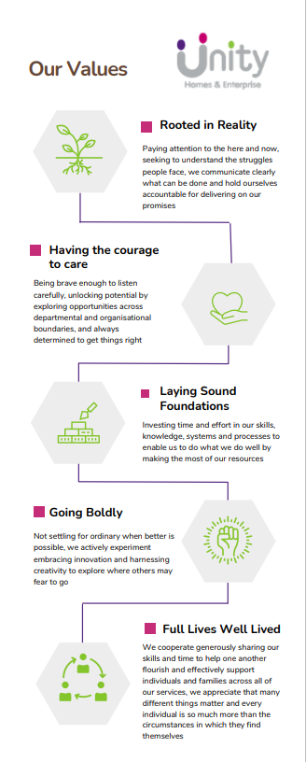
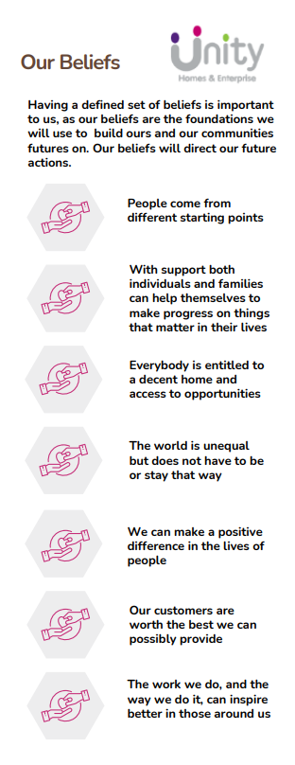

Personal Specification

ATTRIBUTES | RANK | HOW IDENTIFIED
EDUCATION/QUALIFICATIONS
CIH Level 5 Diploma in Housing or willingness to achieve this qualification | Essential | application form

KNOWLEDGE & EXPERIENCE
Recent experience within a housing role | Essential | application form + interview
Strong IT systems literacy (this will be tested at interview) | Essential | application form + interview
Demonstrate a willingness to undertake and can evidence recent continued professional development | Essential | application form
Line management/supervisory experience | Essential | application form + interview
Ability to plan, lead and deliver service charge processes/projects | Essential | application form + interview
Experience in a similar role delivering customer focused service | Essential | application form + interview
Comprehensive understanding of housing legislation and best practice guidance | Essential | application form + interview
Substantial current understanding of Welfare Benefits and their interaction within the Social Housing sector. | Essential | application form + interview
Knowledge, understanding and application of specialist HM / IT software systems and new income or customer service applications/apps/software to improve income efficiency and effectiveness | Essential | application form + interview
Proven track record of income maximisation, interventions and enforcement action. | Desirable | application form

SKILLS AND ABILITIES
Must be able to demonstrate positive leadership and role modelling behaviours | Essential | interview
Ability to draft and write fit for purpose and high-quality Policies and Procedures | Essential | interview
Strong prioritisation and time management of self and direct reports | Essential | application form + interview
Excellent numerousy and IT skills | Essential | application form + interview
Strong report writing & presentation skills | Essential | application form + interview
Ability to draft/ write timely complaint responses to a high standard and to strict deadlines | Essential | application form + interview
Well-developed communication and interpersonal skills | Essential | application form + interview
Ability to take ownership and lead a situation/ project through to completion | Essential | application form + interview
Ability to work under pressure and coordinate a varied and complex workload | Essential | application form + interview
Ability to evaluate, diagnose and find solutions to problems | Essential | application form + interview
Ability to manage, coordinate and finish projects including the income team and other teams within the business | Essential | application form + interview
Mediation & Negotiating skills | Desirable | application form + interview
Coaching and Mentoring Skills Motivational Interviewing Skills | Desirable | application form + interview

DISPOSITION/ATTITUDE
Positive, resilience and can-do attitude | Essential | interview
Ambitious (is driven to do well, be effective, achieve, succeed and progress quickly through the organisation) | Essential | application form + interview
Strong and well developed analytical reasoning (is driven to do well, be effective, achieve and succeed) | Essential | interview + references
Compliance (adheres to policies and/or procedures, or seeks approval from the appropriate Manager/Director or authority before making changes) | Essential | application form + interview
Developing others (develops team's competence by planning effective experiences related to current and future jobs, in the light of individual motivations, interest and  current work situation) | Essential | application form + interview
Empathy (understands the feelings and attitudes of others and is able to put themselves in others' shoes) | Essential | application form + interview
Innovation (is change-oriented and able to generate and/or recognise creative solutions in varying work-related situations) | Essential | application form + interview
Integrity (maintains and promotes organisational, social, and ethical standards and values in the conduct of internal as well as external business activities) | Essential | application form + interview
Listening (draws out opinions and information from others in face-to- face interaction) | Essential | application form + interview
Must be passionate about social housing, empowering and supporting customers to achieve the best for themselves | Essential | application form + interview
Communication (is proficient in both written and verbal communication) | Essential | application form + interview

CIRCUMSTANCES
Attendance is required occasionally at evening meetings | Essential | interview
Have access to a vehicle for business needs/transport or be able to travel between locations efficiently | Essential | application form + interview

